HELLO TURKEY, ROMANIA, BULGARIA AND PORTUGAL

It’s very nice that we can keep in touch despite the prevailing pandemic and difficult conditions. We are so sad that we can’t finish the project this summer, but don’t care, we keep working! Our Polish Erasmus Team has meetings online. Lately we have come up with an idea about presentations related to curiosities of the English-speaking countries. And we decided that each of us will write a letter.

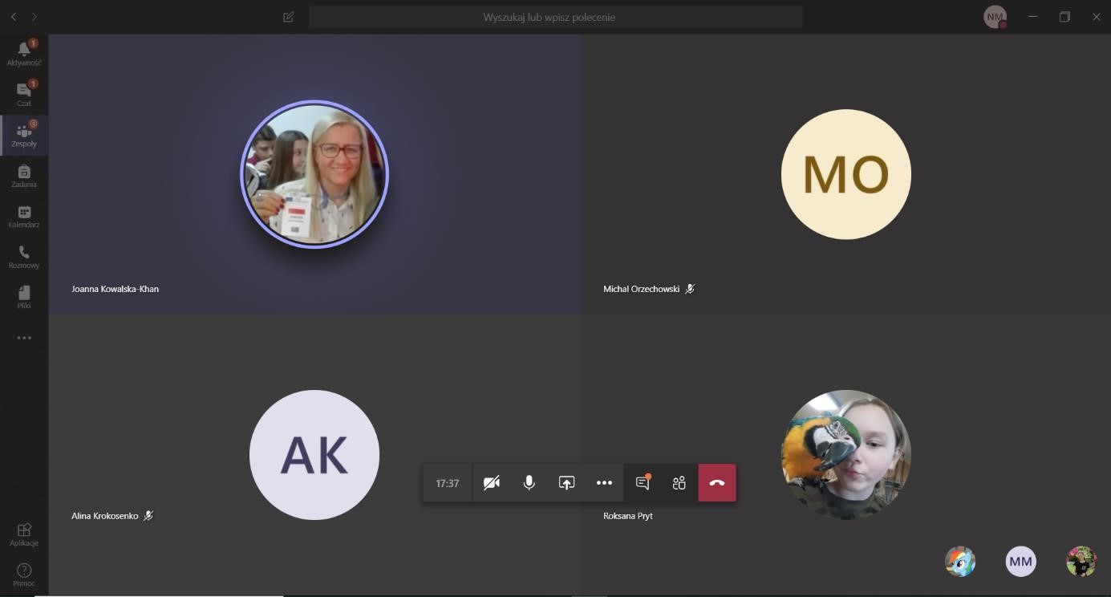

Most of us are going to write an Eighth Grade Exam. Unfortunately, we can’t get prepared at our school, but we do it online! Everyday we solve sample exam sheets and the next day we send them to our teachers.
They check them and send them back to us. I want to tell you that your coming to Poland was great. Nice to met you. We could meet each other and exchange the curiosities of our countries. I hope you enjoyed the games which were prepared by our English teachers.
Unfortunately, we couldn’t fly to Turkey in March. I believe that we will be able to meet, maybe next year. Anyway, I would like to thank you for all work and wish you new successes.

Keep going and don’t give up!
Norbert Matyniak form Poland

