Dear Erasmus Friends,

I would prefer to talk in person in Turkey, but this terrible situation thwarted our plans. I am not writing this letter to complain, but I am curious how are you doing during the pandemic and I’ll tell you what I am doing.
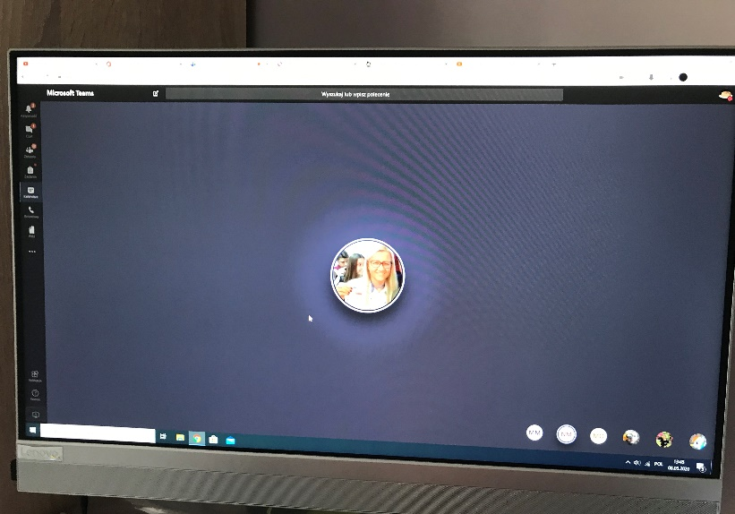
So, first we are learning online. We have a couple of lessons that are obligatory, for example English, Maths and Polish. From other subjects, we have only some tasks to do and to send back to the teachers. We have Erasmus online gatherings too.

Sometimes we have also technical problems with tests like there.
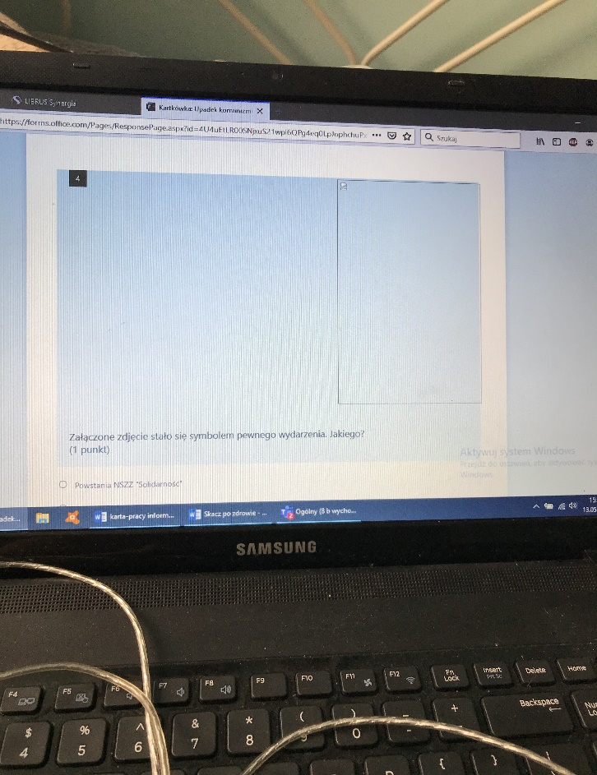

I have also additional English classes online. I prefer real classes, but I must adjust to it. And I have it two times a week like normal, so I won’t lose any classes.

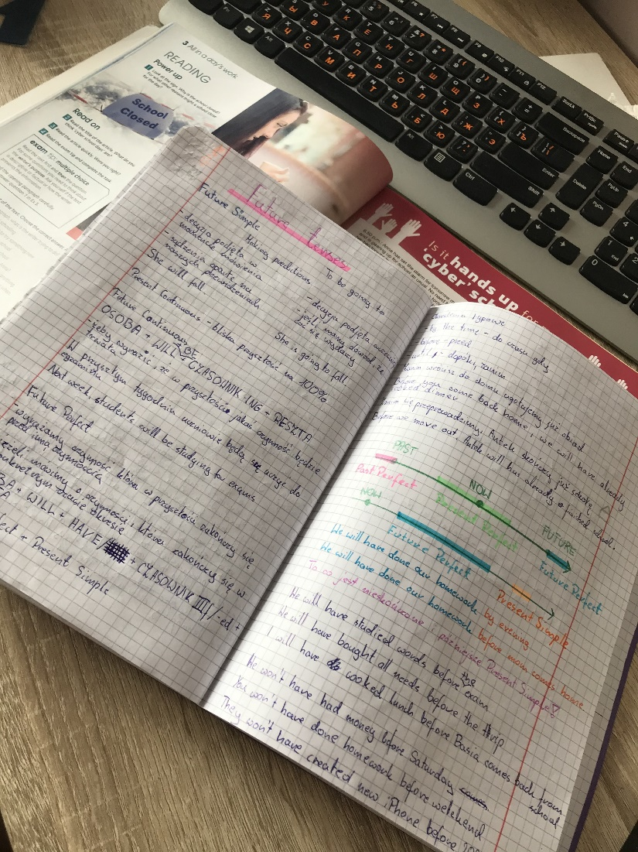
In whole Poland we must wear masks, all concerts are cancelled. Happily, the most of restrictions are lifted so we can say that we’re slowly turning back to normality.
The situation is hard, but the most important is to look at the positives. In Poland pandemic looks like this. How is it in your countries?

Alina Krokosenko from Poland

